(i) The effect in time domain
The z transforms of the transfer function is $H\left(z\right)= \sum_{-inf}^{inf}{h\left[n\right]*z^{-n}}$.
Now replacing z with $z^{D}$, we have $H\left(z^{D}\right)= \sum_{-inf}^{inf}{h\left[n\right]*z^{-n*D}}$ ……………. EQN1
Let k = nD, so $n=\frac{k}{D}$, EQN1 becomes $H\left(z^{D}\right)= \sum_{-inf}^{inf}{h\left[\frac{k}{D}\right]*z^{-k}}$………………EQN2
Which is the z transform of variable k. The h[$\frac{k}{D}$] part of this equation implies that in time domain, the signal will expand by D times.
(ii) The effect in frequency domain
Since k = nD, from the $z^{-k}$ = $z^{nD}$ part of EQN2, we can conclude that the signal will shrink by the factor of D in the frequency domain.
- H(z) is now the transfer function of a LPF with $f_{c}=\frac{pi}{4}$ now, sketch the magnitude response for the following systems

- Let $H_{1}\left(z\right)= 1+αz^{-1}$
- The frequency response of this filter can be calculated as $H_{1}\left(e^{jω}\right)=1+ αe^{-jω}$.
The impulse response coefficients can be calculated by rearranging the original expression of H1 in the form of $\sum_{n=0}^{n=1}{α^{n}*z^{-n}}$, where $α^{n}$is the impulse response coefficient.

- Now $H\left(z\right)=H_{1}\left(z^{D}\right)=1+ αz^{-D}, α>0$.
The frequency response is $H_{1}\left(e^{jωD}\right)=1+ αe^{-jωD}$, and its magnitude can be found by $H_{1}\left(e^{jωD}\right)=1+ α\left(\cos\left(ωD\right)-jsin\left(ωD\right)\right)$
$$=1+αcos\left(ωD\right)-jαsin\left(ωD\right)$$
$$maginitude= \sqrt{{\left(1+αcos\left(ωD\right)\right)}^{2}+{\left(αsin\left(ωD\right)\right)}^{2}}$$
$$= \sqrt{1+2αcos\left(ωD\right)+ α^{2}}$$
It reaches its maximum magnitude when $\cos\left(ωD\right)=1$, mag_max = |1+$α$|
It reaches its minimum magnitude when $\cos\left(ωD\right)=-1$, mag_min = |1-$α$|.
Dips(antiresonance)are the minimum points of an oscillation, recall magnitude has its minimum at cos($ωD$)= -1, this will occur at $ω=\frac{\left(2k+1\right)*pi}{D}, where k=0, 1, 2, …, D-1$. Therefore there are D dips.
Peaks(resonance)are the maximum points of an oscillation, recall magnitude has its maximum at cos($ωD$)= 1, this will occur at $ω=\frac{\left(2k\right)*pi}{D}, where k=0, 1, 2, …, D-1$. Therefore there are D peaks.

The zeros can be found by
$$H_{1}\left(z^{D}\right)=1+ αz^{-D}$$
$$=\frac{z^{D}+α}{z^{D}}$$

When $z^{D}+α =0$, we have our zeros.
$$z^{D} =-α$$
$$z= \sqrt[D]{-α}= \sqrt[D]{α}*\sqrt[D]{e^{j\left(pi+2k*pi\right)}}, where k= 0, 1, 2, …, D-1.$$

Matlab plot when D = 8
- Zeros and Poles
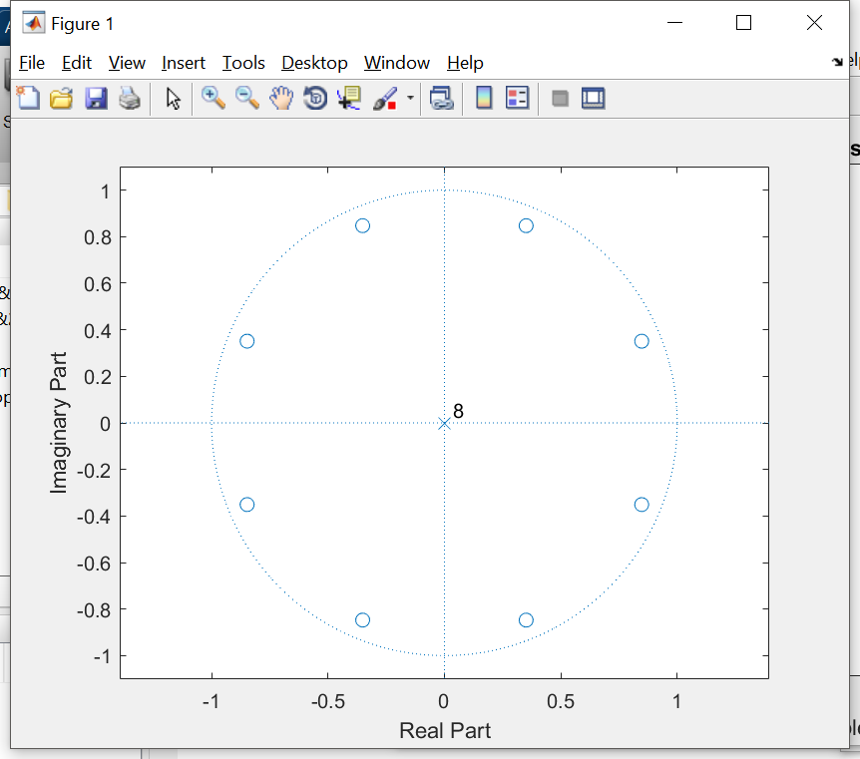
- Impulse response
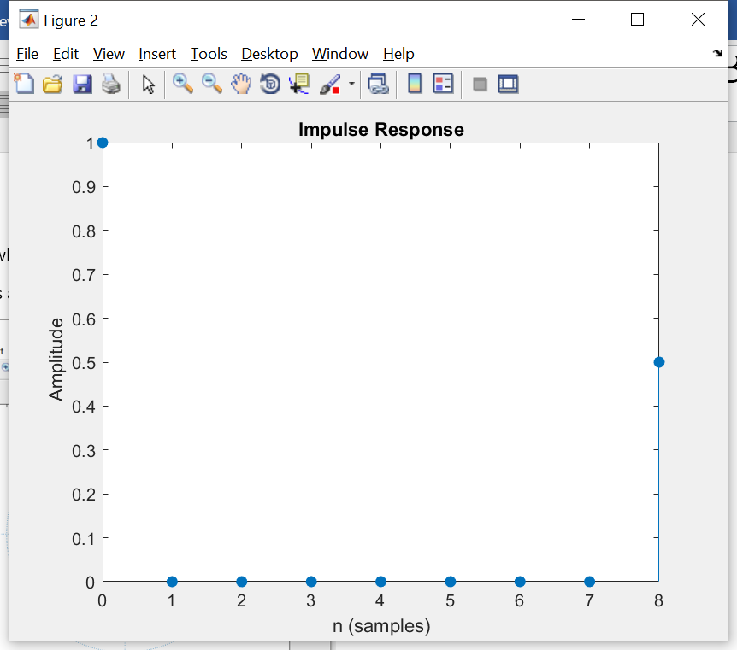

- Magnitude and phase response in [0, 2pi ]
